# **Report and Analysis:**

1. **Data Description:**

Following is the details for dataset given. Like number of variables number of observations after removing **nan** values. With numerical 19 and 2 categorical.

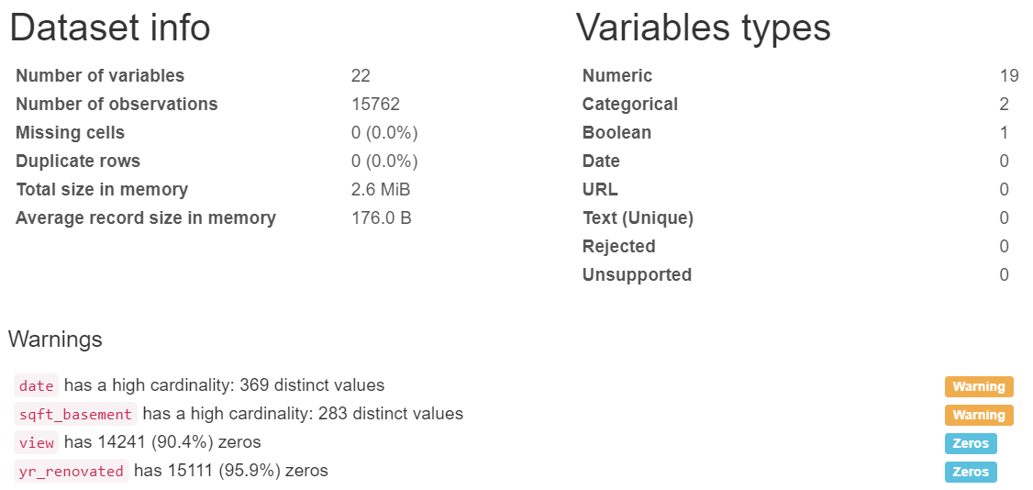

First 10 rows of data.

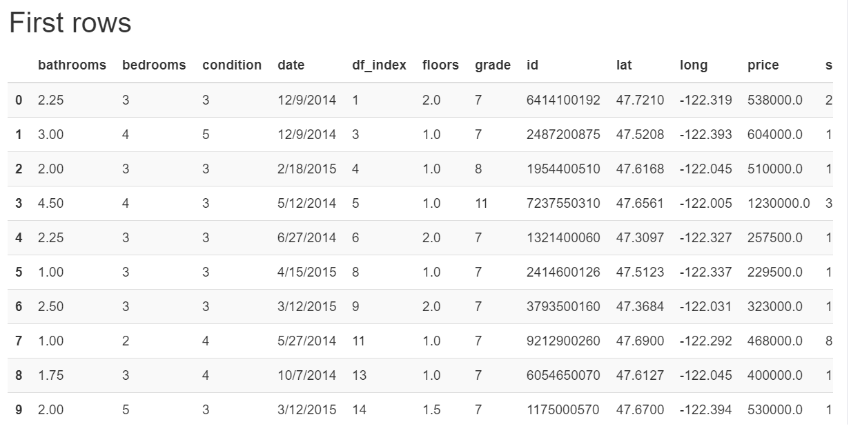

Last 10 rows of data.

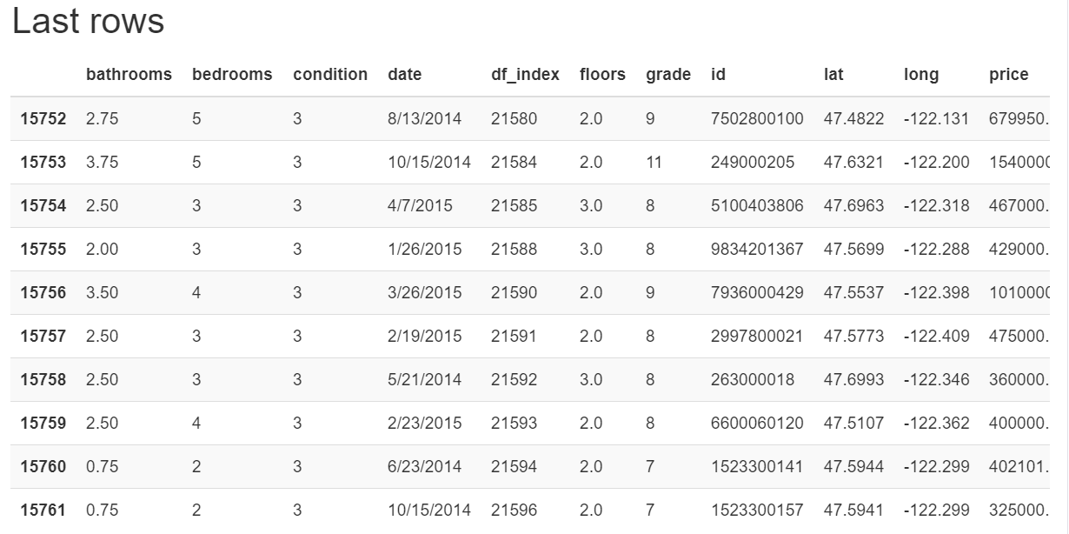

1. **Data measures of centrality and dispersion for all variable:**

Calculation of different measures of centrality and dispersion for dataset like mean, median, mode, max

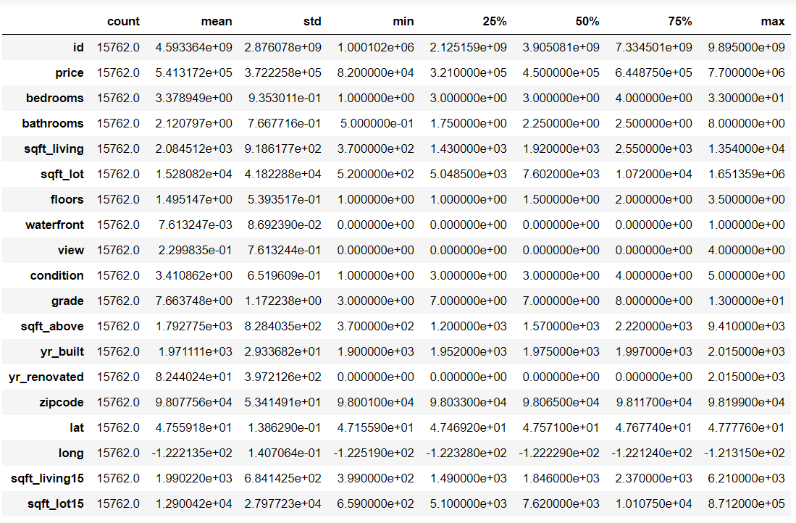

1. **Different matrix for variable selection**

Pearson's r

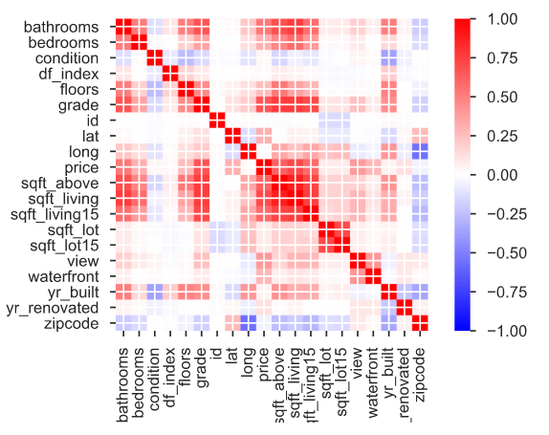

Spearman's ρ

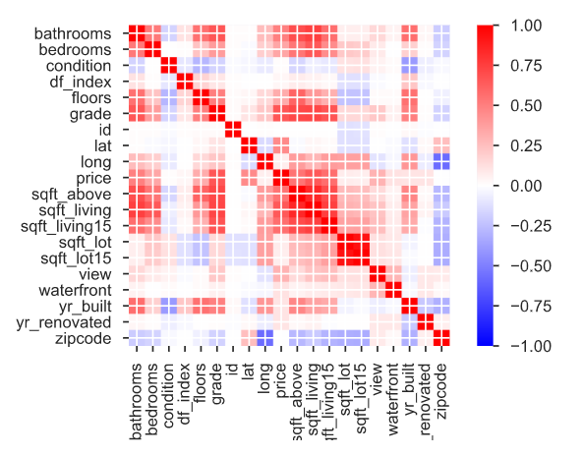

Kendall's τ

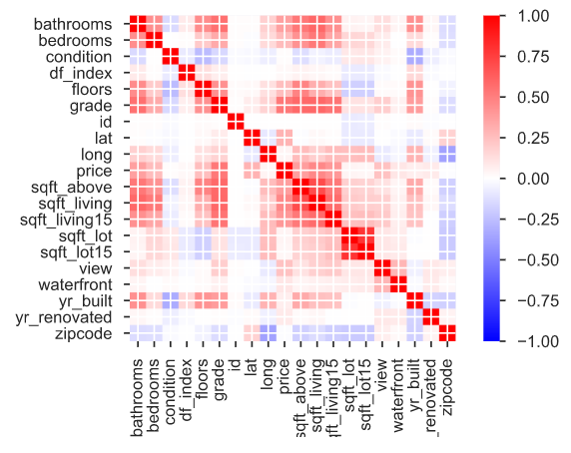

1. **Missing values**

After removing nan there is no missing values.

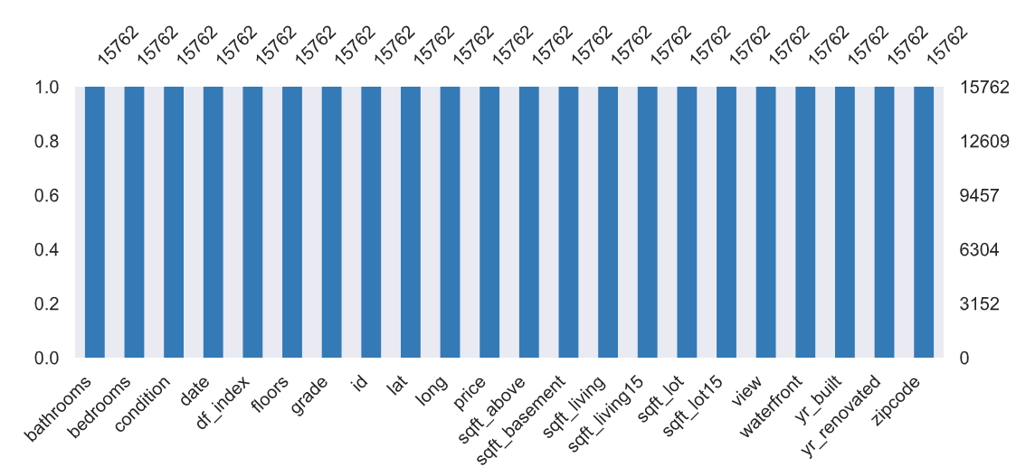

1. **Model training variable selection**

Pair plot for all the variables.

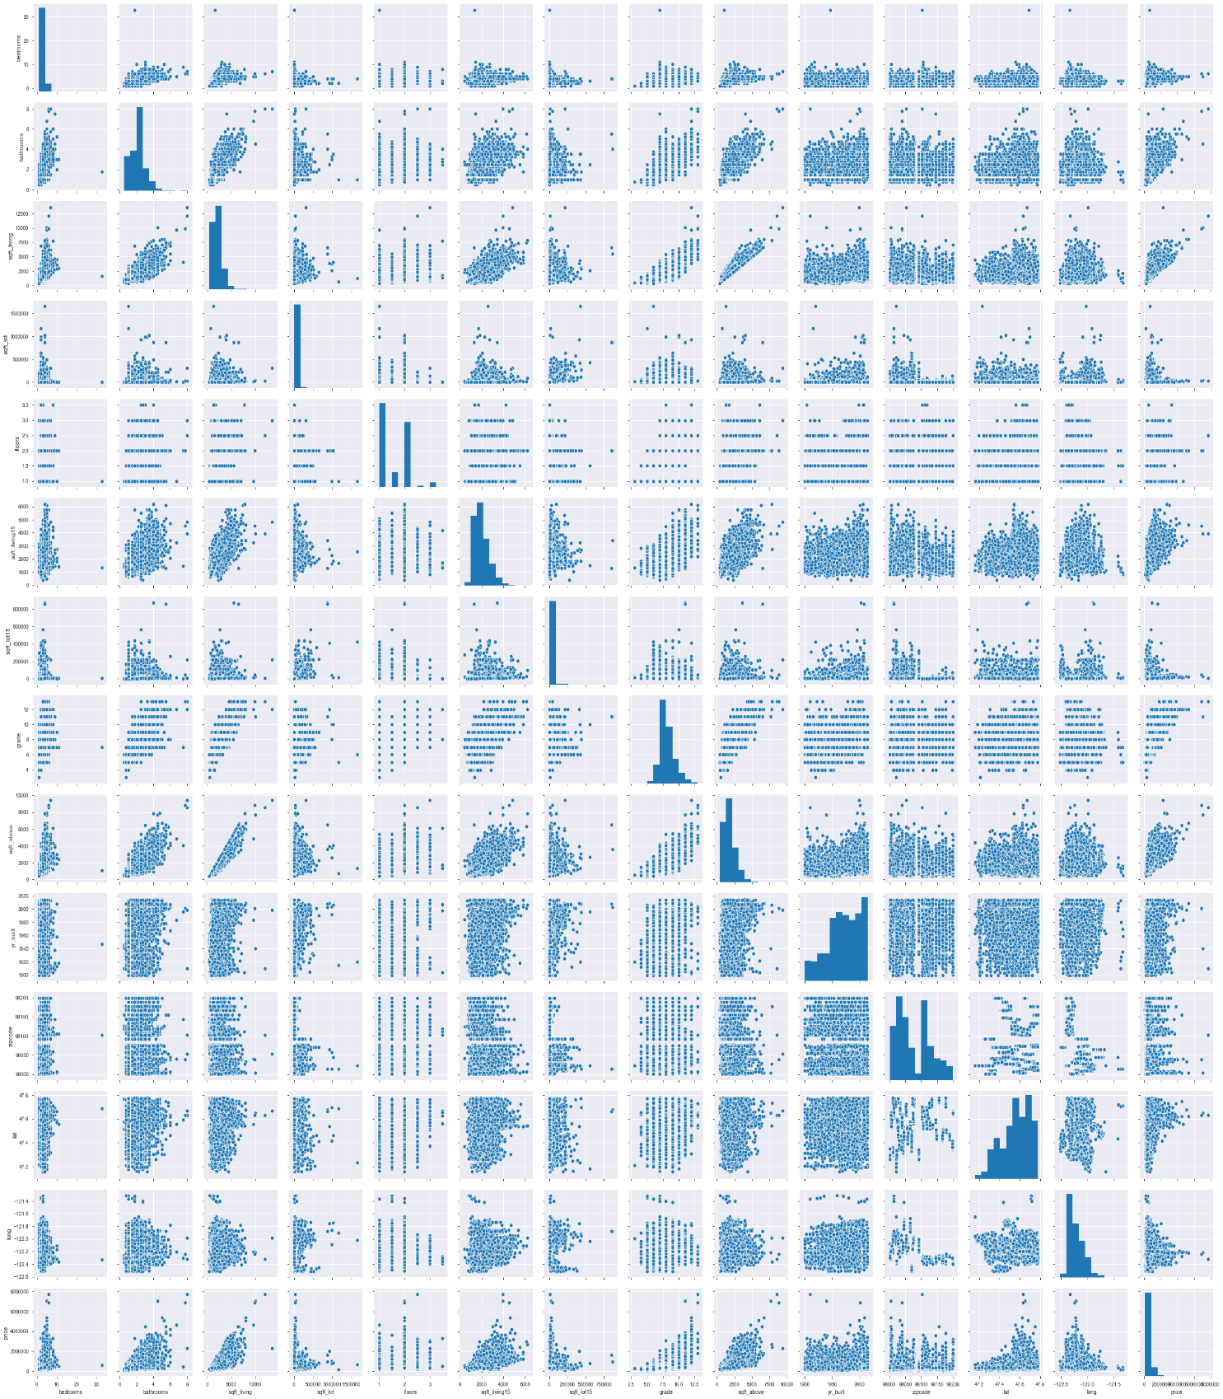

Pair plot for the selected variable.

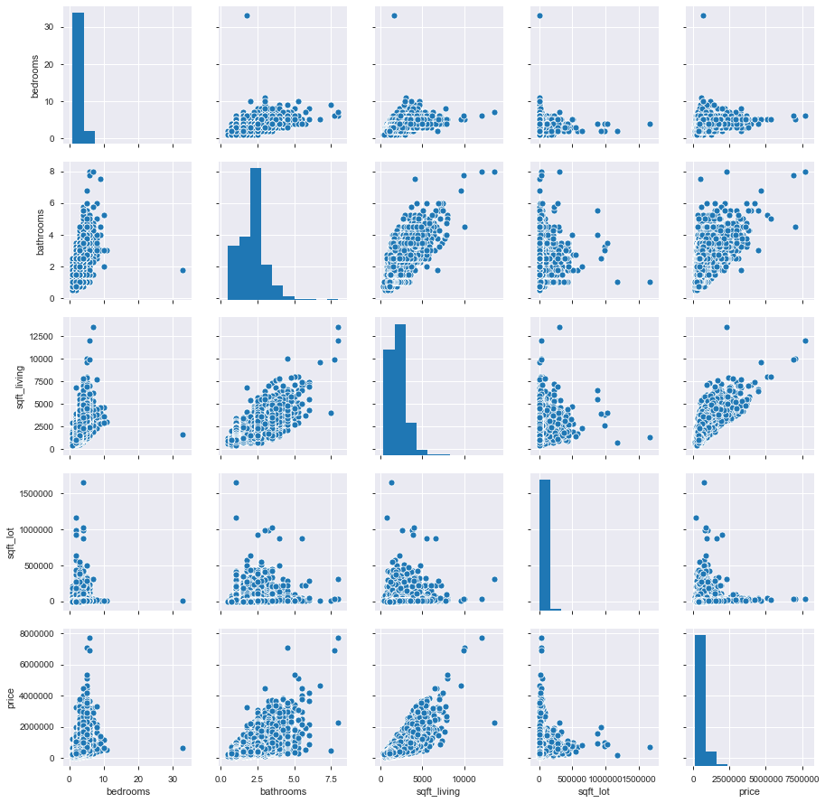

1. **Training Results**
2. Training result as cost vs number of epochs

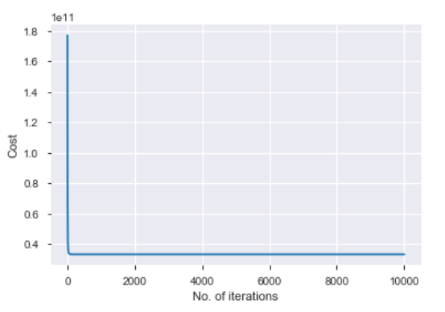

1. R2 and person correlation for prediction

